Title: Data Driven Approach to Predict Success of Bank- Marketing
Group Members:
Dedipya Tangulwar,
Aastha Bhandari,
Trang Nguyen

Dataset: Success of Bank marketing
Bank Marketing Data - dataset by data-society | data.world
Phase 1: Business Understanding

Dataset Overview: The data is related with direct marketing campaigns of a Portuguese banking institution.The marketing campaigns were based on phone calls. Often, more than one contact to the same client was required, in order to assess if the product (bank term deposit) would be (‘yes’) or (‘no’).

Purpose: Improve bank marketing strategy and come up with technology driven solutions to reduce phone calls but increase success rate. The classification goal is to predict if the client will subscribe (yes/no) to a term deposit (variable y).

Problem Statement: Finding out the characteristics that are helping Bank to make customers successfully subscribe for deposits, which helps in increasing campaigns efficiently and selecting high value customers.

Application area: The goal is to build a Machine Learning model that learns the unknown patterns, maps and several input features classifying whether clients will subscribe for longer deposits or not.

- Is there a relationship between a customer's demographic profile and their decision and duration of phone call?
- Does a customer's credit affect the customer’s decision?
- Does the information from the previous campaign help improve the successful rate of calling?

2/ Initial Data Exploration:

Determine potential dependent variables (DV’s) and independent variables (IV’s) from the data set. These are variables that you would use in your analysis according to the business problems addressed in #1

Seq | Role | Variable Name | Type | Description | Missing value | Bar chart
1 | IV | Age | Numeric | age of participants | 0 | 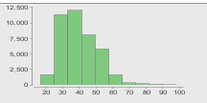
2 | IV | Job | Categorical | type of job | 0 | 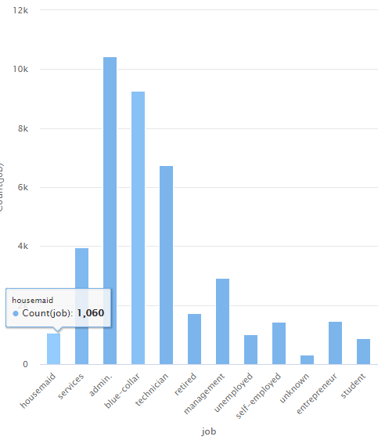
3 | IV | Marital | Categorical | marital status (divorces, married, single, unknow) | 0 | 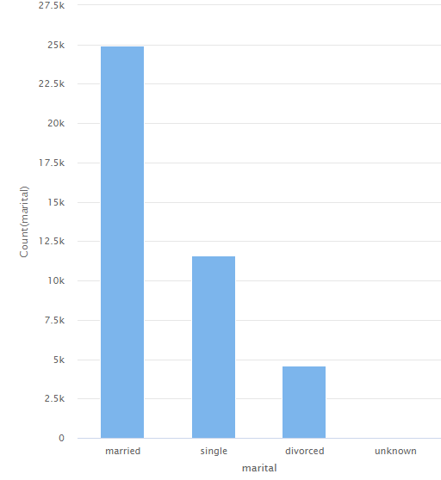
4 | IV | Education | Categorical | ‘basic.4y’,’basic.6y’,’basic.9y’,’high.school’,’illiterate’,’professional.course’,’university.degree’,’unknown’ | 0 | 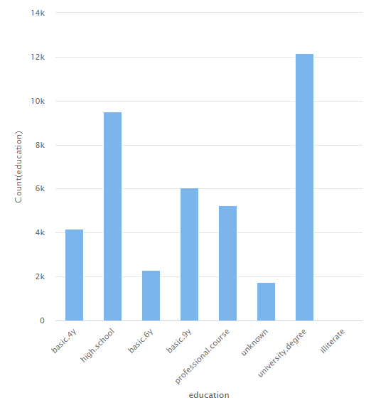
5 | IV | Default | categorical | has credit in default? (Yes, No or Unknown) | 0 | 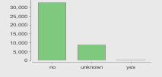
6 | IV | Housing | Categorical | has housing loan? (Yes, No or Unknown) | 0 | 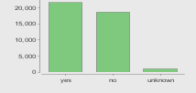
7 | IV | Loan | Categorical | personal loan (Yes, No or Unknown) | 0 | 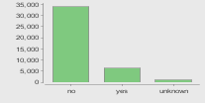
8 | IV | contact | categorical | contact communication type (cell or telephone) | 0 | 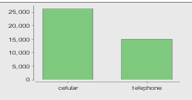
9 | IV | month | categorical | last contact month of year (categorical: ‘jan’, ‘feb’, ‘mar’, …, ‘nov’, ‘dec’) | 0 | 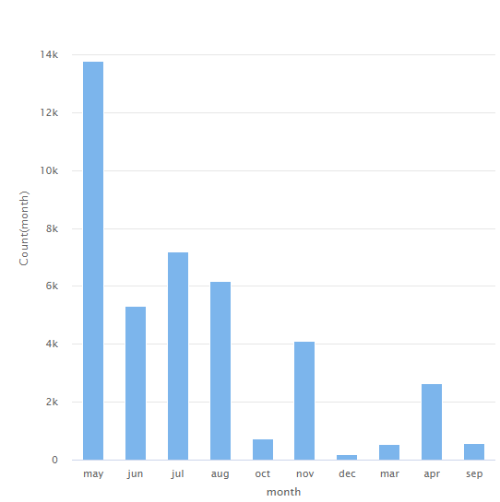
10 | IV | day_of_week | categorical | last contact day of the week (categorical: ‘mon’,’tue’,’wed’,’thu’,’fri’) | 0 | 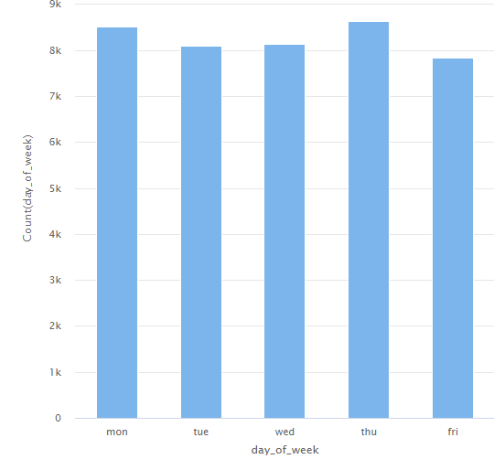
11 | IV | Duration | Numeric | last contact duration, in seconds (numeric)  Important note: this attribute highly affects the output target (e.g., if duration=0 then y=’no’). Yet, the duration is not known before a call is performed. Also, after the end of the call y is obviously known. Thus, this input should only be included for benchmark purposes and should be discarded if the intention is to have a realistic predictive model. | 0 | 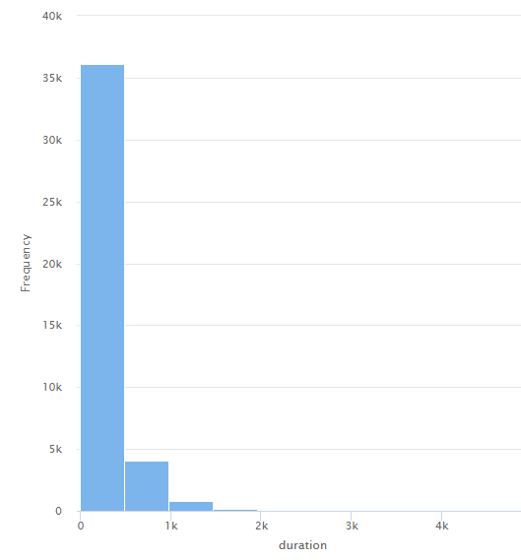
12 | IV | Campaign | Numeric | number of contacts performed during this campaign and for this client (numeric, includes last contact) | 0 | 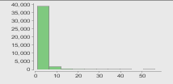
13 | IV | pdays | Numeric | number of days that passed by after the client was last contacted from a previous campaign (numeric; 999 means client was not previously contacted) | 0 | 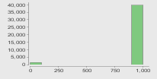
14 | IV | previous | Numeric | number of contacts performed before this campaign and for this client | 0 | 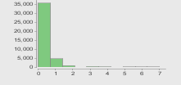
15 | IV | poutcome | Categorical | outcome of the previous marketing campaign (categorical: ‘failure’,’nonexistent’,’success’) | 0 | 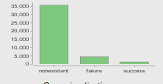
16 | IV | emp.var.rate | numeric | employment variation rate — quarterly indicator | 0 | 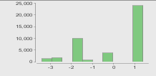
17 | IV | cons.price.idx | numeric | consumer price index — monthly indicator | 0 | 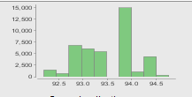
18 | IV | cons.conf.idx | numeric | consumer confidence index — monthly indicator | 0 | 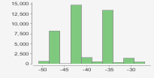
19 | IV | euribor3m | numeric | euribor 3 month rate — daily indicator | 0 | 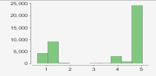
20 | IV | nr.employed | numeric | number of employees — quarterly indicator | 0 | 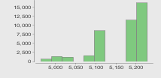
21 | DV | y | categorical | has the client subscribed a term deposit? (binary: ‘yes’, ‘no’) | 0 | 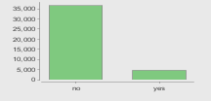

Mean, Mode, Median, Standard Deviation, Minimum and Maximum of Numerical Variables

 | age | duration | campaign | pdays | previous | emp.var.rate | cons.price.idx | cons.conf.idx | euribor3m | nr.employed
Histopgram | In the table above
Mean | 40.02 | 258.29 | 2.57 | 962.48 | 0.17 | 0.08 | 93.58 | (40.50) | 3.62 | 5,167.02
Mode | 31.00 | 85.00 | 1.00 | 999.00 | - | 1.40 | 93.99 | (36.40) | 4.86 | 5,228.00
Median | 38.00 | 180.00 | 2.00 | 999.00 | - | 1.10 | 93.75 | (41.80) | 4.86 | 5,191.00
S.D | 10.42 | 259.28 | 2.77 | 186.91 | 0.50 | 1.57 | 0.58 | 43,628.00 | 1.73 | 72.18
Min | 17.00 | - | 1.00 | - | - | (3.40) | 92.20 | (50.80) | 0.63 | 4,964.00
Max | 98.00 | 4,918.00 | 56.00 | 999.00 | 7.00 | 1.40 | 94.77 | (26.90) | 5.05 | 5,228.00
Q1 | 32.00 | 102.00 | 1.00 | 999.00 | - | (1.80) | 93.08 | (42.70) | 1.34 | 5,099.00
Q3 | 47.00 | 319.00 | 3.00 | 999.00 | - | 1.40 | 93.99 | (36.40) | 4.96 | 5,228.00
IQR | 15.00 | 217.00 | 2.00 | - | - | 3.20 | 0.92 | 6.30 | 3.62 | 129.00
Lower W | 9.50 | (223.50) | (2.00) | 999.00 | - | (6.60) | 91.70 | (52.15) | (4.08) | 4,905.50
Higher W | 69.50 | 644.50 | 6.00 | 999.00 | - | 6.20 | 95.37 | (26.95) | 10.39 | 5,421.50
outliers? | Yes | Yes | Yes | Yes | Yes | No | No | Yes | No | No

Note:
- pdays will not have outliers, 999 means we haven't called this customer before, so we should code this variable more meaningfully.
- cons.conf.idx will not have outliers because the difference is small.
3/ Correlations
a/ The correlation analysis for the numerical variables

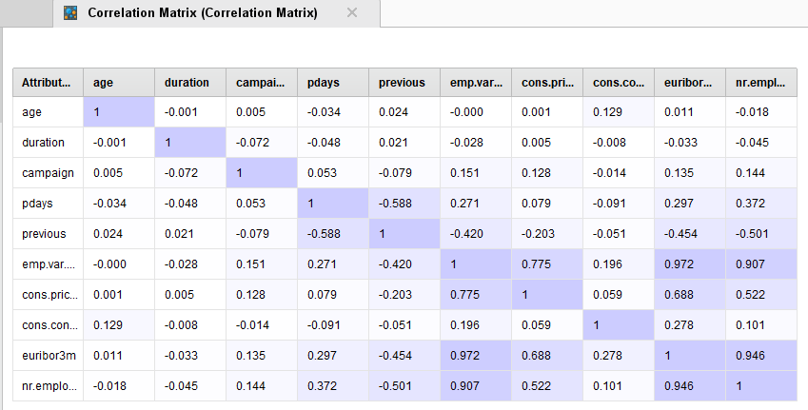

We have 3 pairs of variables have the highest correlation, more than 0.9 for each of pair
- Euribor3m with emp.var rate
- emp.var.rate with nr.employed
- Euribor3m with nr. employed

emp.var.rate with nr.employed (0.907) | Euribor3m with emp.var rate(0.972) | Euribor3 with nr. employed(0.946)
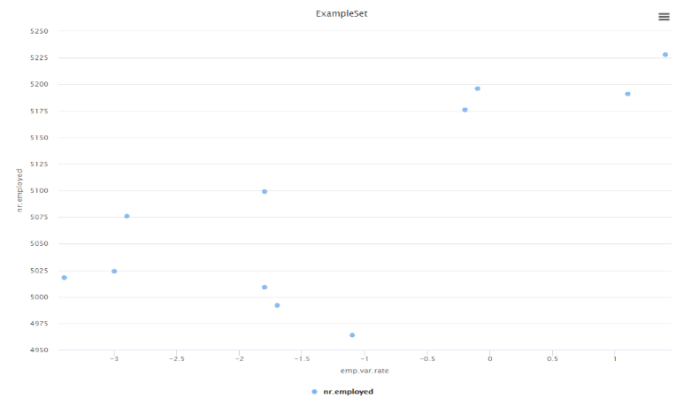 | 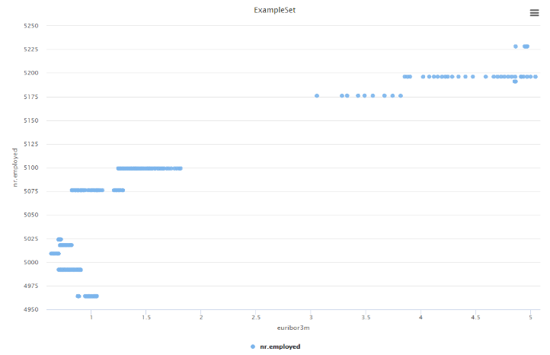 | 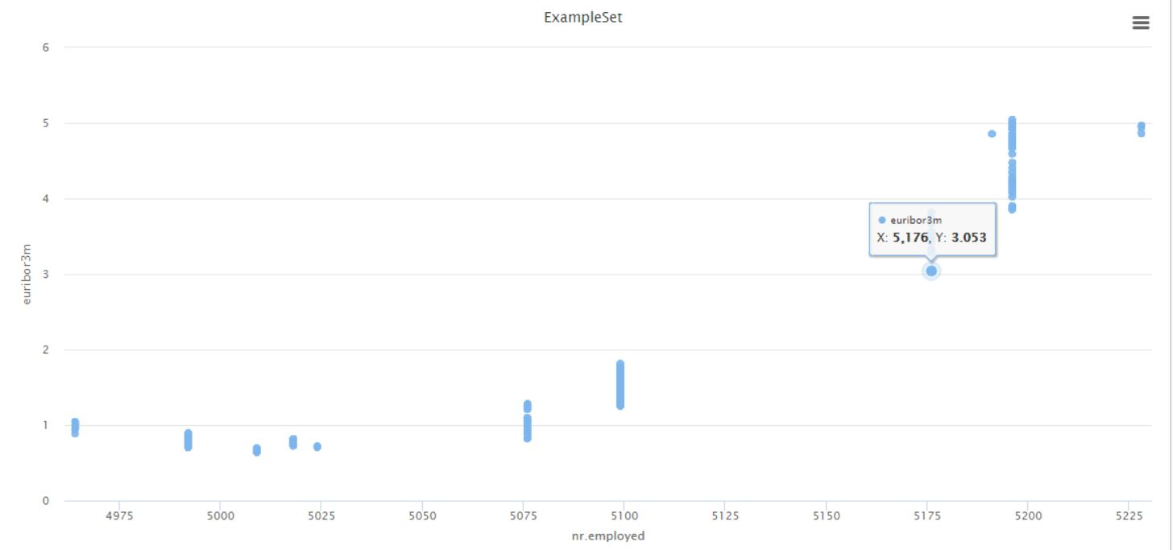

We also have few negative relationships but those are not meaningful (previous, pdays) so we do not continue to interpret or discover them more.

b/ Interpret the results. Is there evidence of a linear relationship between the variables? If so, characterize the relationship. Is it positive or negative? Is it weak or strong?

- Based on scatter plot chart above, there might have been a positive linear relationship between these 3 pairs (emp.var.rate, euribor3m, and nr. employed) numerical variables, as they have strong positive correlation which we can see from the correlation matrix and the distribution of plots in the chart

c/Provide any business cases related to the results of your correlation analysis.

In our case, the three variables belong to social context attributes, which are the index of market:
- emp.var.rate: the employment variation rate, which is the rate between who are employed to the population
- euribor3m: the Euro interbank offered rate, which makes sense because the collected data is from a bank in Portuguese
- nr.employed: number of employees in the population
The definition of each index can show us part of relationship between these variables, when the employment variation rate or the currency rate increases that shall result in the growth of amount of employees (nr.employed)

4/ Multiple Regression – since our DV is binary so we cannot run this regression
5/ Logistic regression:
a/ I would like to test whether customers’ demographic affect much on their response
DV | IV | Type of IV
Y (Cat) | Age  Job  Education  Marital  Default  Housing  Contact  Loan | Num  Cat  Cat  Cat  Cat  Cat  Cat  Cat
a/ The variables are included in the regression model as suggested by RapidMiner’s
Variables affect negatively important | Variables do not affect | Variables affect positively
Job=blue_collar, admin, technician, service, management, entrepreneur  Contact=telephone  Education=basic.9y, high.school, university.degree  … | Job=student  Matrital=unknown  Education=illiterate  Default=unknown, yes  Housing=unknown  Loan=yes, unknown  Contact=cellular | Loan=no  Marital=single  Age  Default=no
- Conclusion: most of unknown values do not affect the customers’ response.
c/ The confusion matrix when the cut-off value is 0.5 (default)
- Accuracy: 88.73%
- Sensitivity: 0.00%
- Specificity: 100%
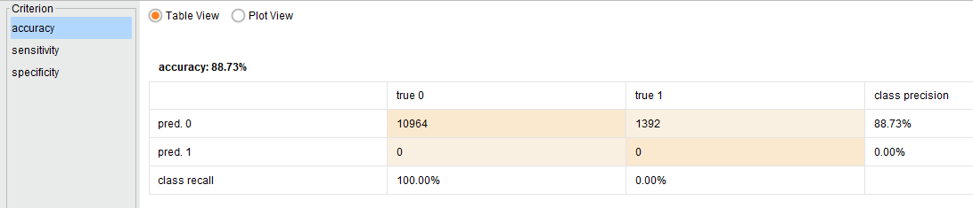
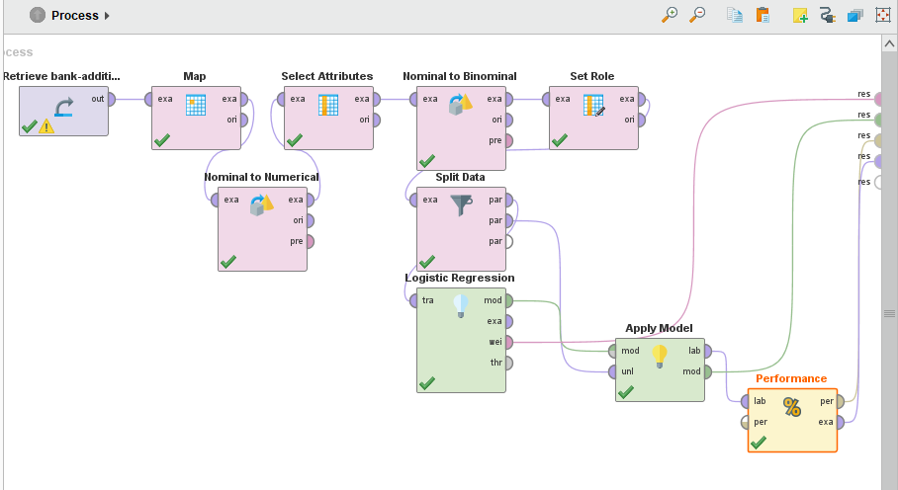
The process in Rapid Miner to define the relationship between DV and set of ID chose above
A lift chart and determine the cut-off value you would use.
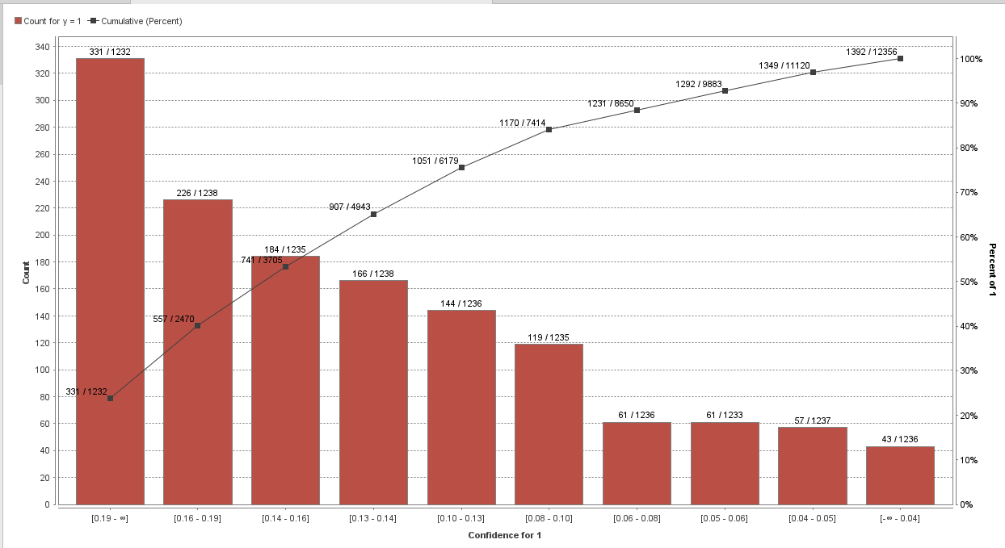
Based on the lift chart, the more customer we ask, the more response “Yes” we will get. However, we would pick the cut-off value around 0.10 because from that point the growing rate Yes response is lower than before with cut-off value at 0.5
d/ Find a optimal cut-off value
The Find Threshold operator to find the optimal cut-off value.
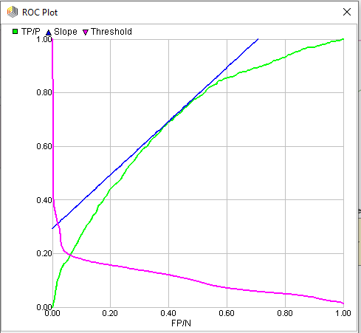

The optimal sensitivity suggested by RapidMiner is 69%
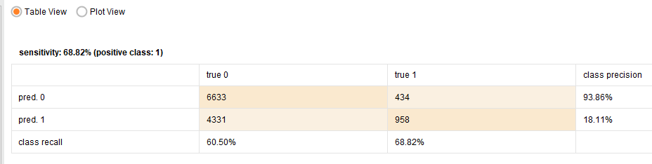
The optimal cut-off value suggested by RapidMiner is 0.4
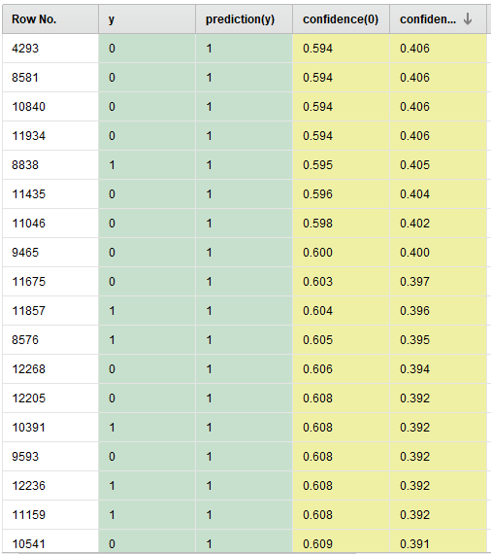

2. Understand whether customers’ credit history and previous campaign information affect the term subscription response.
- selected attributes: Default- credit (yes,no), Campaign (number calls performed), pdays(number of days passed since last contacted), poutcome(failure, nonexistent, success-previous marketing campaign), previous (number of clients contacted in the last campaign), loan, day_of_week, month
- Added filter example operator to remove outliers for variables: (age, duration, and campaign)
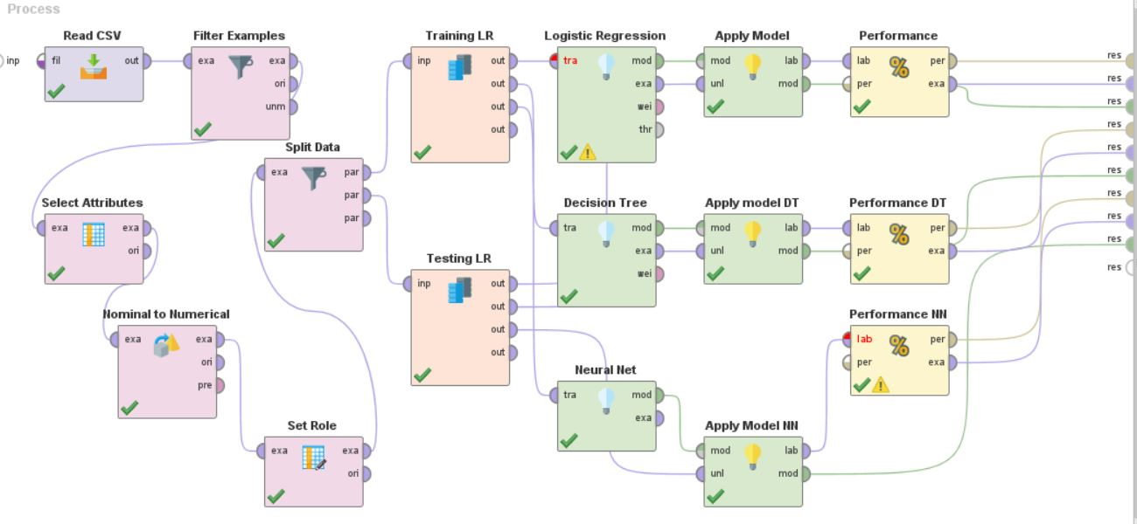
a). Logistic Regression
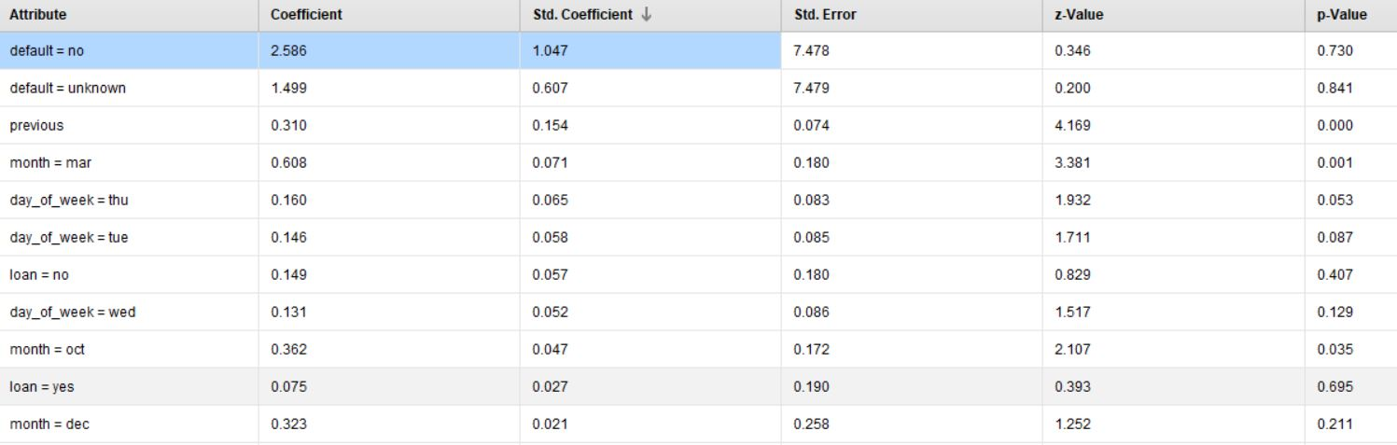
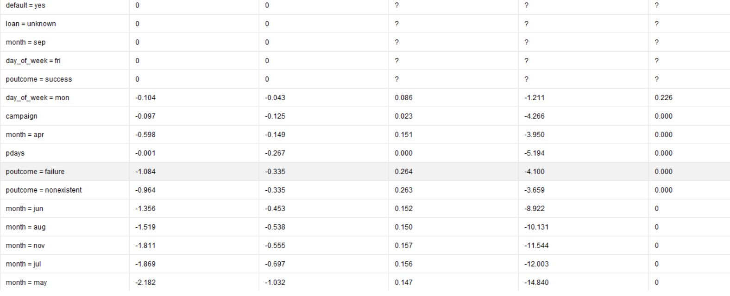
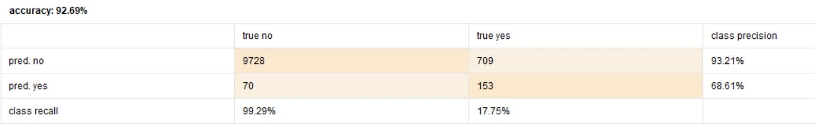
In this context, we can analyze that default (credit history) attribute has more influence on the target variable. Other variables did not, such as loan and pdays.true (days passed since last contacted), outcome, month (may, jun, aug, july, nov) had negative std.coefficient which shows that they have negative relationship with the dependent variable. However, the rapid miner had removed collinearity for specific variables such as default (yes), loan (unknown), month (sept), day of week (fri), and poutcome (success). This could impact how attributes correlate with the dependent variable.
From a business standpoint we can predict current customers’ response rate based on poutcome and credit history of the client from previous campaign data. Even though some variables are negatively correlated, they could also impact the response rate. We need to see what months had low subscriptions so we can improve the marketing strategy. However, in terms of sensitivity of the model there were more customers who did not subscribe for term deposit. Here in (true no class) we can see 98.66% vs. (true yes) was 20.33% shows that based on previous campaign information data there was a high non-subscription rate. Overall, the accuracy of this model was good as it was 92.69%. From the pdays information given, so many people were not contacted before the campaign as a result there might be a low response rate.

b). Decision Tree
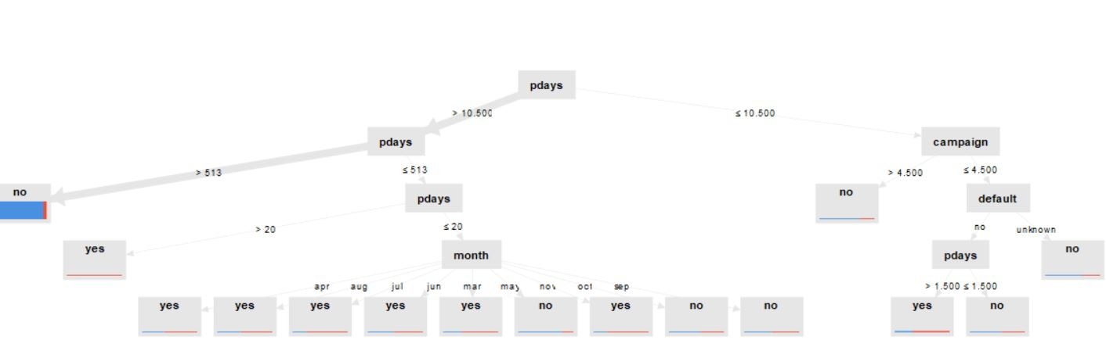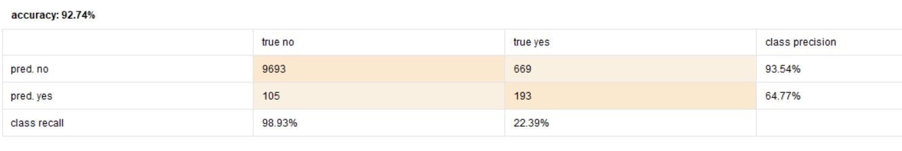

 | Result | Pdays | Result interpretation
1 | No | >10.5 & 513 | (513) represents the number of days since the client was contacted. So greater than 513 days shows that most customers did not subscribe to term deposits because it had been a long time since they were contacted by the bank.
2. | Yes | >20 | means that very few customers have subscribed for a term deposit since last contacted.

 |  | Pdays, Month | Result Interpretation
3. | Yes | <20, April - October | Subscription
4. | No | September-March | No subscription

 |  | Pdays, Campaign | Result interpretation
5. | No | </=10.5, >4.5 | This shows information on the number of calls performed (campaign variable) which impacted the low response rate.

 |  | Default(credit) Pdays | Result Interpretation
6. | No  Yes  No | unknown  No >1.5  </=1.5 | Here in terms of credit information, unknown category customers have not subscribed which needs further investigation as we do not have quality data.  Customers those who do have credit and have subscribed for the term deposit

Trang’ interpretation

Rule | Reponse | pdays | month | campaign | default
1 | No | <513
2 | Yes | 20< x <=513
3 | Yes | <20 | Mar, Apr, Aug, Jul, Nov
4 | Yes | 1.5< x <10.5 |  | <=4.5 | no
5 | No | Other cases

After analysing the decision tree, there are a few factors from campaign information to be considered. The main influencer is pdays which is different in logistic regression. We can understand from this model that attributes (pdays, campaign, credit infomation, and month) have an impact on the response variable. Importantly we see that customers subscribe for term deposits for only six months during the year. Also it is important to note here that those who do not have credit are more likely to subscribe but we do not know their background information as they are in the unknown category. In terms of accuracy this model has 92.74% which is 0.05% higher than the Logistic Regression model.
c). Neural Network
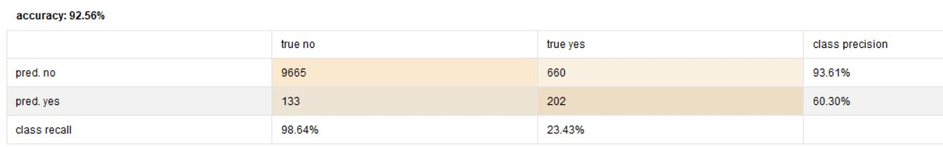
The neural network had 1 hidden layer with 16 nodes. The model’s accuracy is 92.56% which is 0.13% lower than the 1st model (logistic regression) and 0.18% lower than the 2nd model (decision tree). This concludes that Neural network has the lowest accuracy rate. This could be a number of reasons as the data is unbalanced which could have impacted the weights in the hidden layer. The drawback of this model is that from a management perspective interpreting the data is difficult.
Model/Performance | Logistic regression | Decision Tree | Neural networks
Accuracy | 92.69% | 92.74% | 92.56%
Sensitivity | 17.75% | 22.39% | 23.43%
We choose to go with the Decision Tree model in this case as we can analyze meaningful patterns from the data to give rich suggestions to the management team. We have taken credit history and attributes related to previous campaign information into consideration to construct the model. When combining all the three models, the decision tree gave detailed information on customer response rate in specific areas.
We would suggest to the management that certain months of the year are not successful, so they should focus on their marketing strategies to attract their customers. Also in terms of credit history, we found out that those who are in unknown and no category are not subscribing to the term deposit. We have to make a plan on how to target those customers as well.
The management has to investigate demographic profiles of these clients in the unknown/no category to find out the reason for their response. Also, as the number of days increased since last contacted there was low subscription rate for some customers. This means that we need to improve the quality of contacting the customers. Once we understand the demographic profiles for those clients we can connect with the customers in a different way (social media, text messaging, flyers) and do cost benefit analysis accordingly.

